Dutch Lady, Asian Perlite win awards
Linda ArchibaldMonday, January 19, 2015

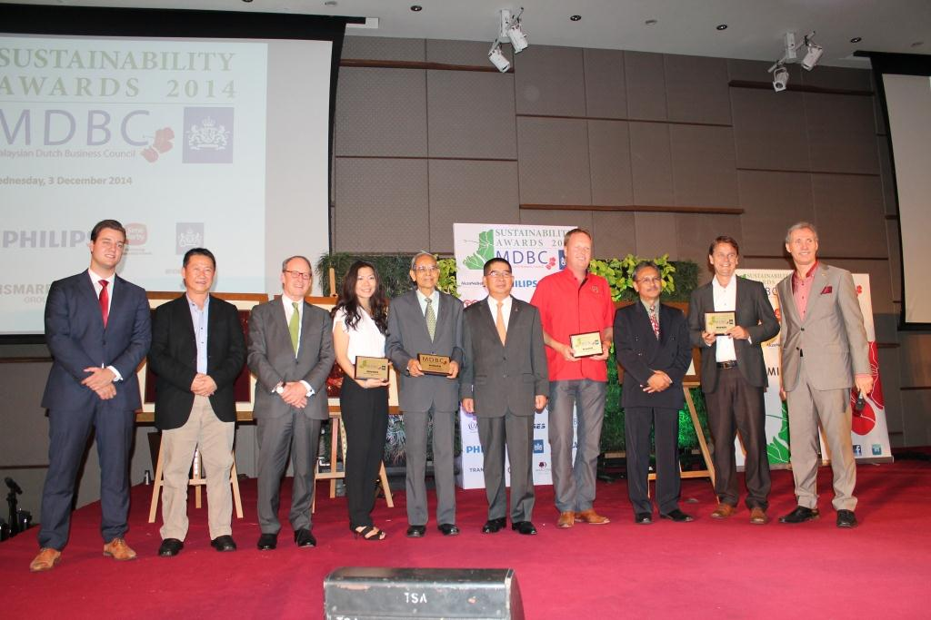
Dutch Lady Milk Industries Bhd took home a business sustainability award for a multinational company (MNC) while Dutch-owned farming SME Asian Perlite Industries Sdn Bhd took home the same category for the small medium enterprise (SME) category.
The two companies were winners of the recent Malaysian Dutch Business Council Sustainability Awards (MSA) 2014.
Dutch Lady, shortlisted alongside Unilever (Malaysia) Holdings Sdn Bhd and Mega Fortris (Malaysia) Sdn Bhd, was chosen winner for having successfully interwoven the three pillars of sustainability – social, economic and environmental – within its operations.
Dutch Lady Milk Industries Bhd (Dutch Lady Malaysia) was named the Best Business Sustainability by a Multinational Company (MNC) at the recent Malaysian Dutch Business Council Sustainability Awards (MSA) 2014.
The company, shortlisted alongside Unilever (Malaysia) Holdings Sdn Bhd and Mega Fortris (Malaysia) Sdn Bhd, was chosen winner for having successfully interwoven the three pillars of sustainability – social, economic and environmental – within its operations.
While the company invests heavily in projects and initiatives to promote good nutrition, particularly for school going children, they have also set environmental sustainability targets to be achieved by 2020 under its Route 2020 programme.
This includes enhancing its production chains to be more efficient and sustainable – from the purchase of purchase of sustainable raw materials to reducing the consumption of energy,
water and waste (water) at its production facilities by achieving at least two percent per year improvement of water and waste (water) efficiency.
To date, the company has put in place strategy and actions to decrease its water footprint with a goal to reduce water usage by 20% per kilo by 2020 compared to 2010 levels, through an efficiency gain of 2% per year. At the same time, various water-recycling improvement projects were undertaken at our production plants.
In addition, its engineering department holds firm to its claim of regular audits of leakages to identify areas of leakages in the plant, taken steps to repair or replace the
faulty pipes to avoid further wastages.
Dutch Lady Malaysia also made efforts to reducing its electricity usage company-wide, though the use of natural gas in its manufacturing operations where the consumption and trend of usage is continuously monitored. They have also established a systematic procedure for the disposal of market-returned products, used packaging materials and scheduled waste.
Asian Perlite, which took home the Best Business Sustainability by a Small Medium Enterprise (SME) at the awards ceremony, manages a sustainable farming and greenhouse solutions for highland farming that helps increase yield per square metre while reduce highland degradation.
The Cameron Highlands-based business, developer of a sustainable greenhouse model suitable for lowlands, has addressed sustainability in the areas of economic, social and environmental.
Established in 1995, the lean team of four focusses on increasing the production of flower and vegetables per square metre to reduce further highland degradation.
The company also promotes reduction in use of chemicals in flowers and vegetables by introducing new products from the Netherlands. The team provides sales, installation and service support for two Dutch companies which produce flower and vegetables grading and packaging lines. ln 2009, the company collaborated with Dutch’s Wageningen University and Research Centre, a greenhouse specially designed for lowland climate in Malaysia.
To date, 52 units of this greenhouse have been set up in Malaysia, while the construction of another 20 units is currently underway.
Asian Perlite is now lobbying for the introduction Koppert biological control products in Malaysian market to help reduce chemical use. Most tourists and consumers are said to be unaware of the particularly high levels of chemical use in vegetables in certain times of the year.
Other winners of MSA include consultancy firm consultancy &samhoud Sdn Bhd which took home the Innovation Pioneer Specialist award.
The inaugural Jaffar Indot Award on Corporate Sustainability was given to Datuk Mizanur Rahman Ghani, who is also a council member of the Federation of Malaysian Manufacturers and an active member of various organisations involved in sustainable development and corporate responsibility including chambers of commerce.
http://themalaysianreserve.com/new/story/dutch-lady-asian-perlite-win-awards

