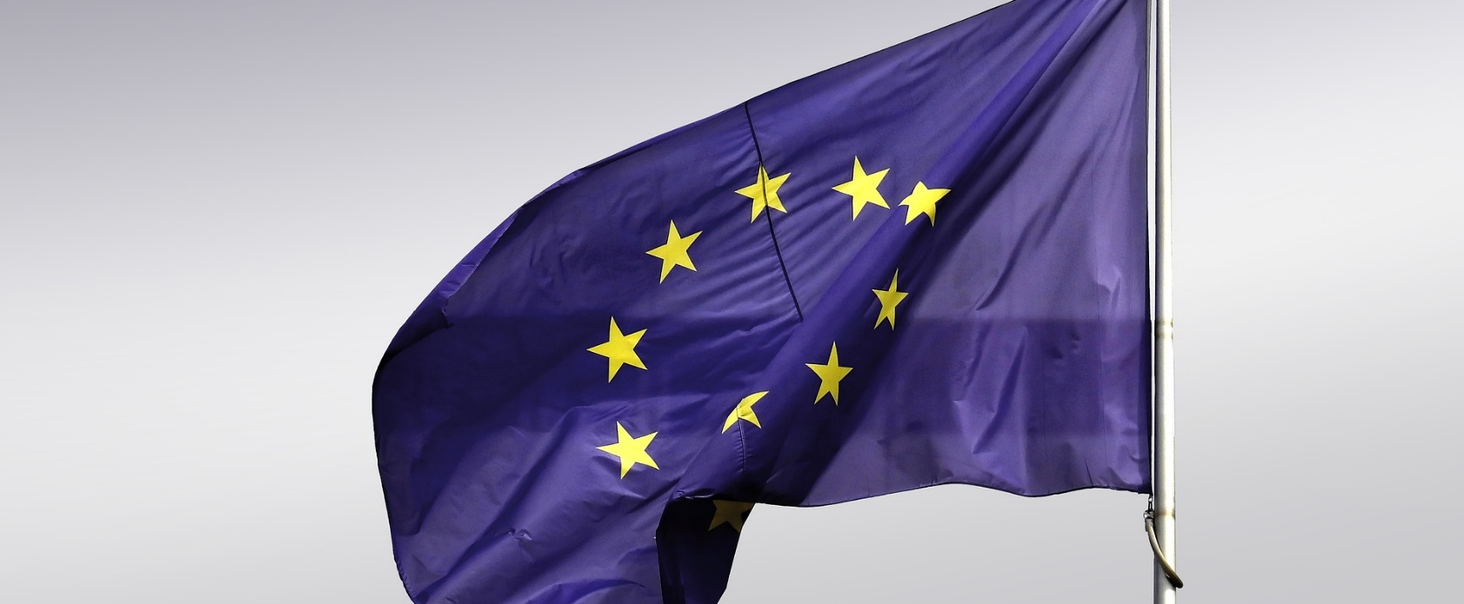
EUROPEAN COMPANY?
LOOKING FOR YOUNG TALENTS?

“EU - Day talent Roadshow” will be organised at three major Malaysian Universities with a duration of one day for each event respectively.
Your company will have a unique opportunity to get in touch with the students directly on their campus. The career fair is for European companies only; hence it is a perfect opportunity to find qualified future employees who are eager to work in an international environment.

The events will take place as follows:
- University Kuala Lumpur (UniKL)
10 April 2019, Kuala Lumpur
- German-Malaysian Institute (GMI)
17 April 2019, Kuala Lumpur
- Sunway University
25 April 2019, Selangor

The participation fee for all 3 locations is RM14,000.00. The price includes a standard shell scheme booth, direct one-to-one talks and presentation of your company to the students at ‘EU Career Symposium’ in every location.

The event is under the Program “Support for European Businesses in Southeast Asian Markets - Malaysia (SEBSEAM-M)”, which is supported by the European Commission, and coordinated by the EU-Malaysian Chamber of Commerce and Industry (EUMCCI)

Come and join us! Slots are limited. Further locations may be considered in the future.
“EU – Day Talent Roadshow”
CAREER FAIR 2019

CAREER FAIR AT
MAJOR MALAYSIAN UNIVERSITIES:
- SELANGOR
- KUALA LUMPUR

- Meet the students on their campuses
- Present your great company
- Get directly in contact to offer internships or vacant positions
- Participate at “EU Career Symposium”

Registration Form

Company:
Contact person/Designation:
Address:

Phone / Mobile No.:
Fax:
Email:
Website:

□ Yes, we would like to participate in all 1 locations for RM 6,000.00 + SST 6%
□ Yes, we would like to participate in all 2 locations for RM 10,000.00 + SST 6%
□ Yes, we would like to participate in all 3 locations for RM 14,000.00 + SST 6%

Each package includes:
- One standard exhibition shell scheme booth (3m x 3m x 2.44m), incl. two chairs, one information counter, carpet;
- Presentation slot of your company at “EU Career Symposium”;
- Direct one-to-one talks with students;
- Drinking water;
- Light catering (3 person max./company)

Date Signature

Registration forms will be processed on a first-come-first-serve-basis.
Registration requires the fully filled form in the stated timeframe.
Please return this form by latest 13th March 2019 to:
Pervinder Singh, Events & Business Support Manager
EU-Malaysia Chamber of Commerce and Industry (EUMCCI)
Tel: +60 3 2162 6298, Email: pervinder@eumcci.com

